Python 3.7.1 (default, Dec 10 2018, 22:54:23) [MSC v.1915 64 bit (AMD64)]

Type "copyright", "credits" or "license" for more information.

IPython 7.7.0 -- An enhanced Interactive Python.

In [**1**]: runfile('C:/Users/Abhi/Documents/PYTHON DSP/Image processing fundamentals/P1.py', wdir='C:/Users/Abhi/Documents/PYTHON DSP/Image processing fundamentals')

[[ 0 0 0 ... 16 16 16]

[ 1 1 1 ... 16 16 16]

[ 1 1 1 ... 16 16 16]

...

[ 2 2 2 ... 1 1 1]

[ 2 2 2 ... 1 1 1]

[ 2 2 2 ... 1 1 1]]

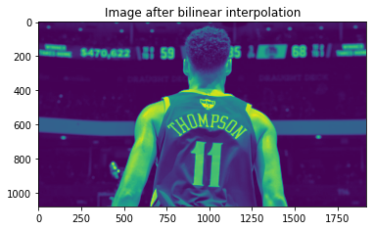

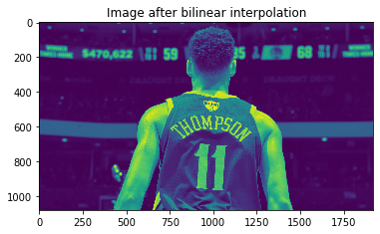

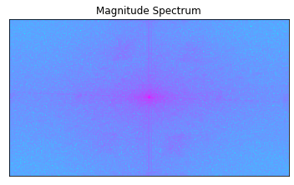

In [**2**]: runfile('C:/Users/Abhi/Documents/PYTHON DSP/Image processing fundamentals/P1.py', wdir='C:/Users/Abhi/Documents/PYTHON DSP/Image processing fundamentals')

[[ 0 0 0 ... 16 16 16]

[ 1 1 1 ... 16 16 16]

[ 1 1 1 ... 16 16 16]

...

[ 2 2 2 ... 1 1 1]

[ 2 2 2 ... 1 1 1]

[ 2 2 2 ... 1 1 1]]



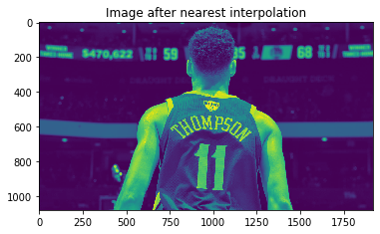



In [**3**]: runfile('C:/Users/Abhi/Documents/PYTHON DSP/Image processing fundamentals/P@.py', wdir='C:/Users/Abhi/Documents/PYTHON DSP/Image processing fundamentals')

[[ 0 0 0 ... 16 16 16]

[ 1 1 1 ... 16 16 16]

[ 1 1 1 ... 16 16 16]

...

[ 2 2 2 ... 1 1 1]

[ 2 2 2 ... 1 1 1]

[ 2 2 2 ... 1 1 1]]

In [**4**]: plt.imshow(dst)

Out[**4**]: <matplotlib.image.AxesImage at 0x1588105bcc0>

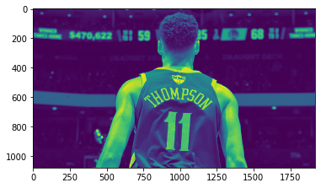

In [**5**]: plt.imshow(img)

Out[**5**]: <matplotlib.image.AxesImage at 0x158810be898>

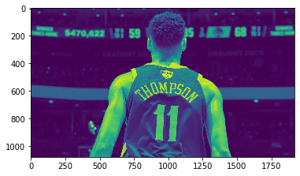

In [**6**]: runfile('C:/Users/Abhi/Documents/PYTHON DSP/Image processing fundamentals/P@.py', wdir='C:/Users/Abhi/Documents/PYTHON DSP/Image processing fundamentals')

[[ 0 0 0 ... 16 16 16]

[ 1 1 1 ... 16 16 16]

[ 1 1 1 ... 16 16 16]

...

[ 2 2 2 ... 1 1 1]

[ 2 2 2 ... 1 1 1]

[ 2 2 2 ... 1 1 1]]

Traceback (most recent call last):

File "<ipython-input-6-495ebf271cb0>", line 1, in <module>

runfile('C:/Users/Abhi/Documents/PYTHON DSP/Image processing fundamentals/P@.py', wdir='C:/Users/Abhi/Documents/PYTHON DSP/Image processing fundamentals')

File "C:\Users\Abhi\Anaconda3\lib\site-packages\spyder_kernels\customize\spydercustomize.py", line 827, in runfile

execfile(filename, namespace)

File "C:\Users\Abhi\Anaconda3\lib\site-packages\spyder_kernels\customize\spydercustomize.py", line 110, in execfile

exec(compile(f.read(), filename, 'exec'), namespace)

File "C:/Users/Abhi/Documents/PYTHON DSP/Image processing fundamentals/P@.py", line 20, in <module>

dst = cv2.filter2D(img,-1,kernel)

TypeError: kernel is not a numpy array, neither a scalar

In [**7**]:

In [**7**]: runfile('C:/Users/Abhi/Documents/PYTHON DSP/Image processing fundamentals/P@.py', wdir='C:/Users/Abhi/Documents/PYTHON DSP/Image processing fundamentals')

[[ 0 0 0 ... 16 16 16]

[ 1 1 1 ... 16 16 16]

[ 1 1 1 ... 16 16 16]

...

[ 2 2 2 ... 1 1 1]

[ 2 2 2 ... 1 1 1]

[ 2 2 2 ... 1 1 1]]

Traceback (most recent call last):

File "<ipython-input-7-495ebf271cb0>", line 1, in <module>

runfile('C:/Users/Abhi/Documents/PYTHON DSP/Image processing fundamentals/P@.py', wdir='C:/Users/Abhi/Documents/PYTHON DSP/Image processing fundamentals')

File "C:\Users\Abhi\Anaconda3\lib\site-packages\spyder_kernels\customize\spydercustomize.py", line 827, in runfile

execfile(filename, namespace)

File "C:\Users\Abhi\Anaconda3\lib\site-packages\spyder_kernels\customize\spydercustomize.py", line 110, in execfile

exec(compile(f.read(), filename, 'exec'), namespace)

File "C:/Users/Abhi/Documents/PYTHON DSP/Image processing fundamentals/P@.py", line 20, in <module>

dst = cv2.filter2D(img,-1,kernel)

TypeError: kernel data type = 8 is not supported

In [**8**]:

In [**8**]: runfile('C:/Users/Abhi/Documents/PYTHON DSP/Image processing fundamentals/P@.py', wdir='C:/Users/Abhi/Documents/PYTHON DSP/Image processing fundamentals')

[[ 0 0 0 ... 16 16 16]

[ 1 1 1 ... 16 16 16]

[ 1 1 1 ... 16 16 16]

...

[ 2 2 2 ... 1 1 1]

[ 2 2 2 ... 1 1 1]

[ 2 2 2 ... 1 1 1]]

In [**9**]: runfile('C:/Users/Abhi/Documents/PYTHON DSP/Image processing fundamentals/P@.py', wdir='C:/Users/Abhi/Documents/PYTHON DSP/Image processing fundamentals')

[[ 0 0 0 ... 16 16 16]

[ 1 1 1 ... 16 16 16]

[ 1 1 1 ... 16 16 16]

...

[ 2 2 2 ... 1 1 1]

[ 2 2 2 ... 1 1 1]

[ 2 2 2 ... 1 1 1]]

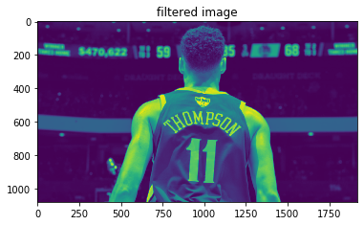

In [**10**]: runfile('C:/Users/Abhi/Documents/PYTHON DSP/Image processing fundamentals/P@.py', wdir='C:/Users/Abhi/Documents/PYTHON DSP/Image processing fundamentals')

[[ 0 0 0 ... 16 16 16]

[ 1 1 1 ... 16 16 16]

[ 1 1 1 ... 16 16 16]

...

[ 2 2 2 ... 1 1 1]

[ 2 2 2 ... 1 1 1]

[ 2 2 2 ... 1 1 1]]



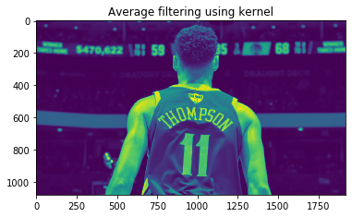

In [**11**]: runfile('C:/Users/Abhi/Documents/PYTHON DSP/Image processing fundamentals/P@.py', wdir='C:/Users/Abhi/Documents/PYTHON DSP/Image processing fundamentals')

[[ 0 0 0 ... 16 16 16]

[ 1 1 1 ... 16 16 16]

[ 1 1 1 ... 16 16 16]

...

[ 2 2 2 ... 1 1 1]

[ 2 2 2 ... 1 1 1]

[ 2 2 2 ... 1 1 1]]





In [**12**]: plt.imshow(median)

Out[**12**]: <matplotlib.image.AxesImage at 0x15881f09470>

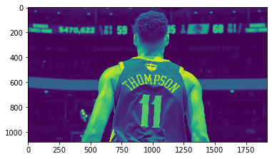

In [**13**]: runfile('C:/Users/Abhi/Documents/PYTHON DSP/Image processing fundamentals/P@.py', wdir='C:/Users/Abhi/Documents/PYTHON DSP/Image processing fundamentals')

[[ 0 0 0 ... 16 16 16]

[ 1 1 1 ... 16 16 16]

[ 1 1 1 ... 16 16 16]

...

[ 2 2 2 ... 1 1 1]

[ 2 2 2 ... 1 1 1]

[ 2 2 2 ... 1 1 1]]





